# Publish Rules from Test to PRD

1. Remote desktop to TDCI01SQL
2. Using SSMS connect to TDCI01SQL
3. Execute SQL Agent Job “Backup CodeDev”

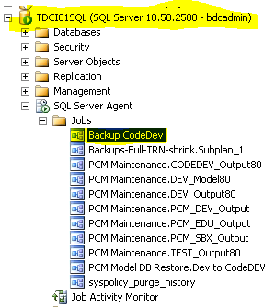

1. Open a command prompt and copy the file below into the window and hit enter
   1. C:\Infor\CopyDatabase - codeDEV to PRD.bat
   2. Verify the database has been copied to this shared drive (\\TDCI01SQLPROD\Backup)
2. Execute SQL Agent Job “PCM Model DB Restore.CodeDEV to Test Model”

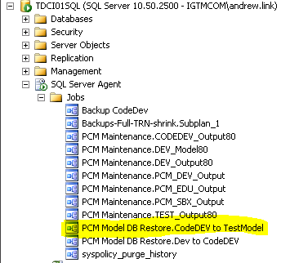

Note: the user running the bat file will need access to both the source and target folders referenced in the bat file

1. Connect to TDCI01SQLPROD in SSMS and execute the SQL Agent Job “PCM Maintenance.Restore CodeDev to PROD”

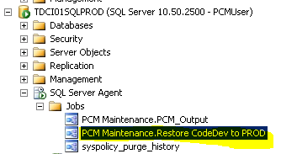

Note: the user running the bat file will need access to both the source and target folders referenced in the bat file

**Below is no longer needed but kept as a reference.**

**TURN TRACING BACK ON**

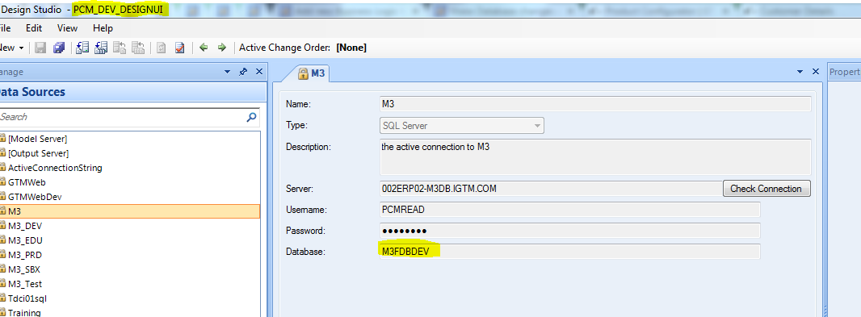

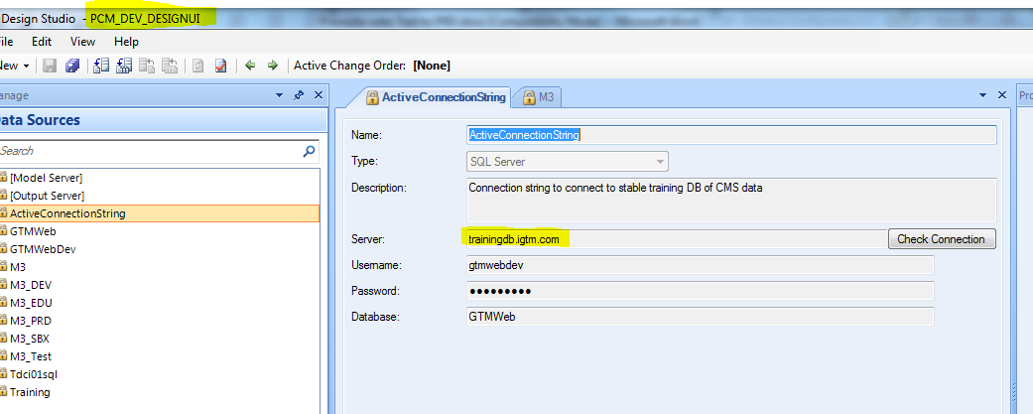

**Fix PCM_DEV_DESIGNUI Data Source (M3 and ActiveConnectionString)**

**ActiveConnectionString: Server needs /training removed from the end of trainingdb.igtm.com**

**M3: Database needs to be M3FDBDEV instead of M3FDBTST**